**Q1.**

Create an image of size 32×32 pixels that consist of a unit impulse at location (16,16) and zeros elsewhere. Use this image and a kernel of your choice to confirm that your function is indeed performing convolution. Display your results and explain what you did and why.

**Answer:**

we first create the image with a unit impulse at location (16,16) by initializing a 32x32 array with zeros and setting the value at (16,16) to 1.

Next, we define the kernel as a 3x3 matrix. In this example, I've chosen a simple kernel for illustration purposes, where each element is set to a constant value. You can choose a different kernel based on your requirements.

Then, we use the convolve2d function from SciPy to perform the convolution. The mode='same' parameter ensures that the output has the same size as the input image. The boundary='fill' and fillvalue=0 parameters handle the border conditions during convolution.

Finally, we display the original image and the convolved image using Matplotlib which we can see in Figure 1.

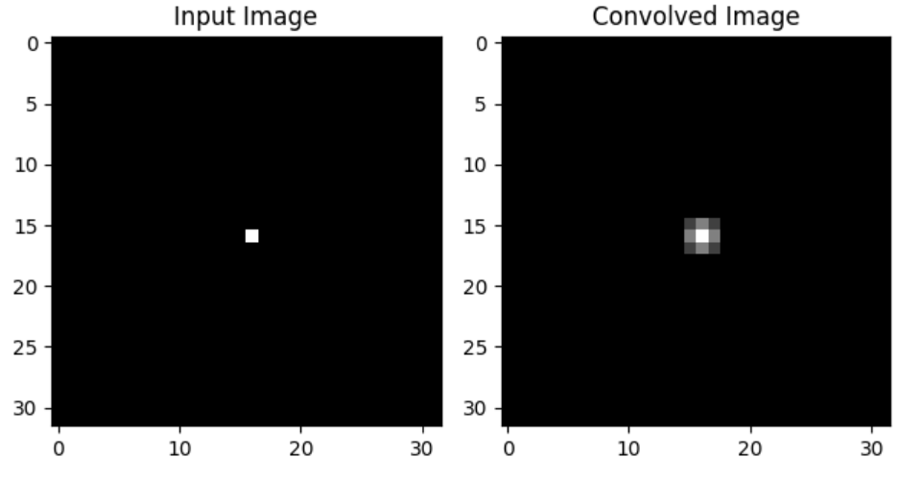

Figure 1

The purpose of this code is to visually confirm that the function is indeed performing convolution. By convolving the image with the kernel, we obtain the convolved image, where the impulse at (16,16) gets spread and influences the neighboring pixels based on the weights defined by the kernel. This demonstrates the fundamental operation of convolution.

**Q2.** Create a reconstruction of an input image (of your choice) from its Fourier transform - first by using only the magnitude response, second by using only the phase response, and lastly by using both magnitude and phase responses. These methods are described in the 1983 research paper [Oppenheim, A. V., Lim, J. S., & Curtis, S. R. (1983). Signal synthesis and reconstruction from partial Fourier-domain information. JOSA, 73(11), 1413-1420].

**Answer:**

**Reconstruction using only the magnitude response:**

Take the magnitude spectrum of the Fourier transform of the image while discarding the phase information. Generate a random phase spectrum of the same size as the original image. Combine the magnitude spectrum with the random phase spectrum to obtain the Fourier transform. Perform an inverse Fourier transform to obtain the reconstructed image. Using only the magnitude spectrum will result in a reconstructed image that lacks important visual information

**Reconstruction using only the phase response:**

Take the phase spectrum of the Fourier transform of the image while discarding the magnitude information. Generate a constant magnitude spectrum of the same size as the original image (e.g., set all magnitudes to 1). Combine the constant magnitude spectrum with the phase spectrum to obtain the Fourier transform. Perform an inverse Fourier transform to obtain the reconstructed image.

**Reconstruction using both magnitude and phase responses:**

Take both the magnitude and phase spectra of the Fourier transform of the image. Generate a random phase spectrum of the same size as the original image. Combine the original magnitude spectrum with the random phase spectrum to obtain the Fourier transform. Perform an inverse Fourier transform to obtain the reconstructed image.

**Results difference:** The reconstruction using both magnitude and phase responses (Method 3) provides the most accurate representation of the original image, preserving both the intensity and spatial information. The reconstruction using only the phase response (Method 2) retains the structural details but loses the intensity information. The reconstruction using only the magnitude response (Method 1) preserves the intensity information but loses the spatial details and structure.